Mechanics
Kinematics for particles
1、equation of motion and path equation
(1)equation of motion
(a)vector form：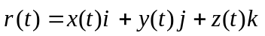
(b)components form：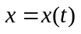，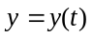，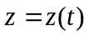
(2) path equation f(x,y,z)=0 (cancel out time t)
2、Quantities of describing motion
(1)
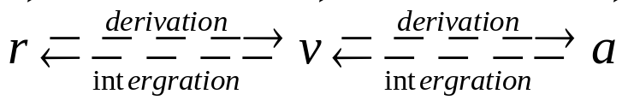
Hints: (a) train rule
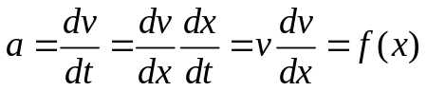
(b) initial conditions
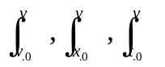
(2) position vector 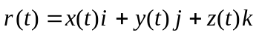
displacement 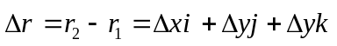
velocity 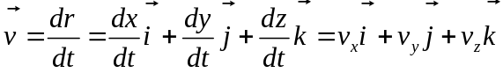
acceleration
a. rectangular coordinate system
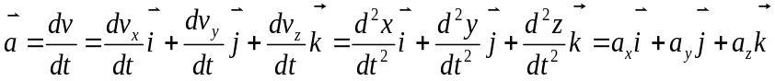
b. natural coordinate system
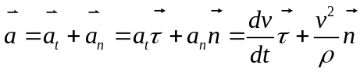
3 、Projectile motion
(1) characteristic:
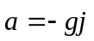 Uniformly accelerated motion
(2) .motion equation
a. component form
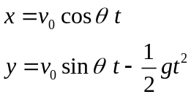
b. vector form
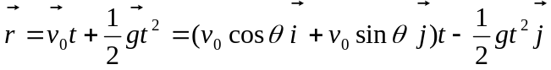
4、circular motion
(1) angular variables
（angular coordinate）
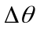（angular displacement）
(angular velocity) 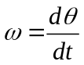
(angular acceleration) 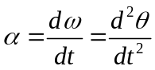
(2) relation between linear and angular variables
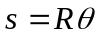, 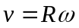
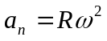 (normal acceleration)
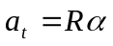 (tangential acceleration)
5、Relative motion
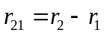
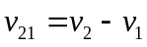
position transform 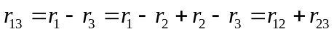
velocity transform 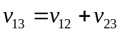
acceleration transform 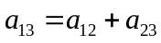

Dynamics for particles
1. Newton’s laws of motion
(1). Newton’s first law of motion (law of inertia)
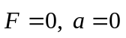
Every body continues in its state of rest or of uniform speed in a straight line as long as no net force acts on it.
(2)． Newton’s second law of motion
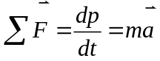
The acceleration of an object is directly proportional to the net force acting on it and is inversely proportional to its mass. The direction of the acceleration is the direction of the net force acting on the object.

(3)．Newton’s third law of motion
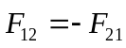
Whenever one object exerts a force on a second object, the second exerts an equal and opposite force on the first.
2. common forces
(1) elastic force:
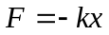(restoring force) k: spring constant，
(2) frictional force 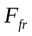
a. kinetic friction 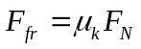
b. static friction 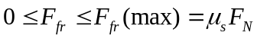
(3) Gravitation:
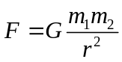 ,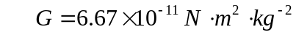 Gravitational constant
(4) Weight 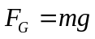
Application of Newton’s laws
- Draw a free-body diagram for every object whose motion is to be analyzed.
- Label all forces acting on the objects.
- Choose a coordinate system for each object under consideration
- Apply Newton’s second law in component form.
- Additional geometric and other constrains may need to be considered in some cases in order to have enough equations.
- Algebraically solve for the unknowns first, then substitute numbers to obtain quantitative answers. This allows you to check your work more easily and reduces errors in calculations.
- Algebraically solve for the unknowns first, then substitute numbers to obtain quantitative answers. This allows you to check your work more easily and reduces errors in calculations.
3. work and energy
(1). work 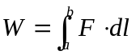
power 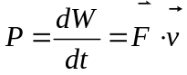
(2) Conservative force：Work done by the force depends only on the initial and final positions.
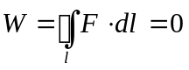
(3). potential energy
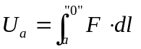, “0” represents zero potential energy.
Weight potential energy 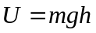
Gravitational potential energy 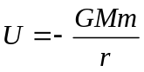
Elastic potential energy 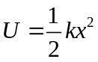
4 .The work-energy principle and conservation of mechanical energy
(1) The work-energy principle
 for one particle
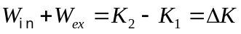 for system of particles
The net work done on an object (system) is equal to the change in its kinetic energy
(2) The work-energy principle
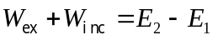
(3) Principle of conservation of mechanical energy
If only conservative forces are doing work, the total mechanical energy of a system is conserved.
5、linear momentum and its conservation
(1). impulse: 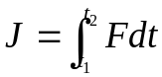
(2). impulse theorem
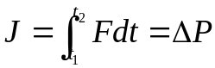 (for particle)
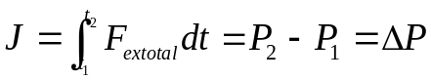（for system of particles）
The change in momentum of an object is equal to the impulse acting on it.
(3) The law of conservation of linear momentum
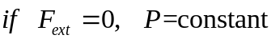
When the net external force on a system is zero, the total momentum remains constant.
6 .Center of mass (CM)
(1) position of CM ：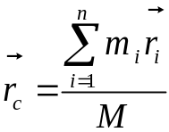 (discrete particles)
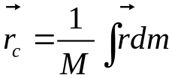 (continuous body)
（2） Newton’s second law for CM
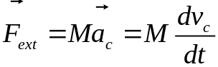
The sum of all the forces acting on the system is equal to the total mass of the system times acceleration of its center of mass.
7. Collisions
The momentum can be considered to be conservative
（1）Conservation of kinetic energy
(perfect) elastic collision
Conservation of momentum and kinetic energy
（2）Lose kinetic energy
Inelastic collision
Completely inelastic collision: the loss of energy is a maximum.
（3）Gain kinetic energy
superelastic collision

